1. Added AppConfig.java to register beans:

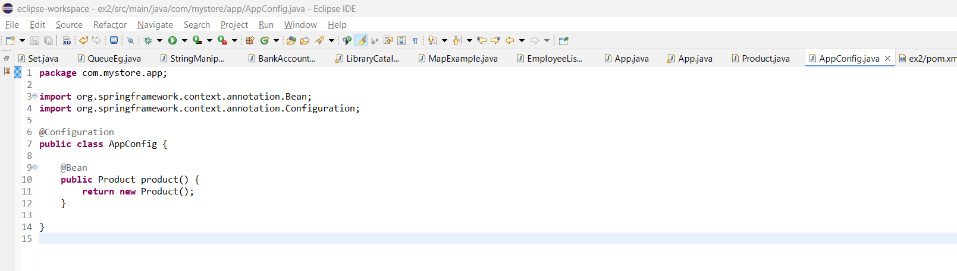

2. Added context in App.java to access beans

